PROPOSAL of GNEN LECTURE PROGRAM in FY 2018
by Japanese University Network for Global Nuclear Human Resource Development (JUNET-GNHRD)

The Japanese University Network for Global Nuclear Human Resource Development (JUNET-GNHRD) will propose to provide following four lectures in FY2018 through telecommunication network (“distance learning”) of the Global Nuclear Education Network (GNEN) for the further development of expertise in the nuclear field.

JUNET-GNHRD was established in December 2010 under a cooperation of 19 universities for efficient and effective sharing of their educational resources and capabilities with close collaboration of the industry and relevant governmental agencies. The member universities of the JUNET-GNHRD are Hokkaido University, Hachinohe Institute of Technology, Ibaraki University, Nagaoka University of Technology, Shonan Institute of Technology, Tokai University, University of Yamanashi, Kanazawa University, University of Fukui, Nagoya University, Kyoto University, Osaka University, Osaka Sangyo University, Kinki University, Okayama University, Kyushu University, Waseda University, Tokyo City University and Tokyo Institute of Technology.

Lecture 1
Title: How safety approaches, methods and goals could be improved in light of the Fukushima-Daiichi Accident?
Date: 16 October, 2018
Lecturer: Prof. Akira Omoto (Tokyo Institute of Technology)

The lecture discusses areas needing improvements for safety in the areas of;
Risk assessment, Deterministic approach, Safety Goals, Defense in Depth, EPR,
Resilience, Effective regulation, Nexus between safety and security and Culture for safety.

Lecture 2
Title: Nuclear power as a sustainable source of energy
Date: 12 November, 2018
Lecturer: Prof. W.F.G van Rooijen (Fukui University)
Nuclear energy is the only source of energy which has zero emissions, and is large scale, reliable, stable, and economically competetive at the same time. In this lecture, we will focus on the technical aspects of nuclear power as a sustainable source of energy:
the nuclear fuel cycle, consumption of natural resources, nuclear waste, and related topics. The student will get a good understanding of the meaning of "sustainable" power and the role of nuclear power therein.

Lecture 3
Title: Fundamentals of nuclear reactor kinetics
Date: 16 November, 2018
Lecturer: Prof. Go Chiba (Hokkaido University)

Lecture summary:
Nuclear reactor kinetics is important and interesting subject in the nuclear engineering. In this lecture, some fundamental knowledge to understand the nuclear reactor kinetics will be explained and role of delayed neutrons will be emphasized.

Lecture 4
Title: Risk and Risk Management
Date: 25 February, 2019
Lecturer: Prof. Akira Omoto (Tokyo Institute of Technology)

The lecture has four parts;
1. Risk and uncertainty
2. Risk assessment and risk management
3. Considerations in risk management: Decision-making, Accident rooted in history and culture, Goals and effectiveness to achieve goals, Consideration of risks in their totality
4. Precautionary Principles and Regulatory Science

Time schedule for each lectures will be in the following time frame;
Thailand Time Malaysian Time Japan Time
Indonesian Time
Vietnam Time
Opening Remarks: 9:00 - 9:05 10:00 -10:05 11:00 - 11:05
Lecture: 9:05 - 10:30 10:05 - 11:30 11:05 - 12:30
Q&A Session: 10:30 - 11:00 11:30 - 12:00 12:30 - 13:00

Curriculum Vitae of Lecturers:
Prof. Dr. Akira Omoto
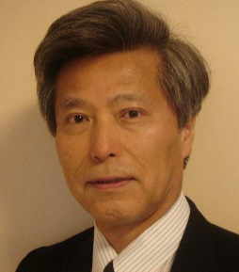
Project Professor, Tokyo Institute of Technology

Background: Nuclear engineer by education & training
  - Graduated from Department of Nuclear Engineering, University of Tokyo
  - Dr. of Engineering from University of Tokyo

Area of interest
  - Risk Management
  - Nuclear Energy Policy

Professional carrier
  - Nuclear Risk Research Center, CRIEPI (Advisor)
  - University of Tokyo (Project Professor)
  - Atomic Energy Commission of Japan(Commissioner)
  - IAEA (Director, Division of Nuclear Power)
  - TEPCO (General Manager, Nuclear Engineering Department)
Work at TEPCO involved: Construction project management, Design engineering, Core and Safety, Licensing

Prof. Dr. W.F.G. van ROOIJEN

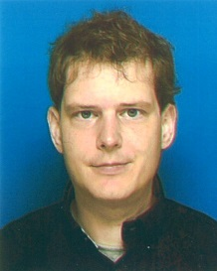
Associate Professor，University of Fukui
The Research Institute of Nuclear Engineering

Willem van Rooijen holds an M.Sc. degree in Applied Physics of Delft University of Technology (The Netherlands), an post-graduate degree in Japanese Business, Language and Culture of Leiden University (The Netherlands), and a Ph.D. in nuclear reactor physics from Delft University of Technology. He has worked as an assistant professor at GeorgiaTech in the USA and at JAEA as a special researcher. He is currently Associate Professor at the University of Fukui in Japan. His specialism is nuclear reactor physics, numerical simulation, fuel cycle analysis, and reactor design & analysis.

Prof. Dr. Go Chiba

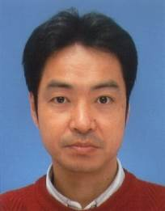
Associate Professor, Doctor of Engineering,
Laboratory of Nuclear Reactor Engineering, Faculty of Engineering,
Hokkaido University, Japan

Professor Chiba worked on the nuclear reactor physics at Japan Atomic Energy Agency for ten years, and moved to Hokkaido University in 2011. His current research subjects are development of numerical methods and codes about the nuclear reactor physics including radiation transport and nuclides transmutation, sensitivity and uncertainty analyses for reactor physics parameters, core design study of advanced nuclear systems and nuclear data validation/benchmarking.
Questionnaire
Lecture for Global Nuclear Education Network by JUNET-GNHRD 2018

Name:
University:
Faculty, School:
Date: ______________________

Please check appropriate box on level, usefulness, interest and expectation.

Level | Usefulness | Interest | Expect more lectures
□ Too advanced  □ Advanced  □ Just right  □ Elementary | □ Much useful  □ Fairly useful  □ Useful  □ A little useful | □ Much interesting  □ Fairly interesting  □ Interesting  □ A little interesting | □ Strongly expect  □ A little expect  □ Different Topics  （ ）
Comments: (Request of contents, proposal for future lecture etc.)

Thank you very much for your cooperation!

